IBM ASSIGNMENT 2

|  |  |
| --- | --- |
| Team ID | Team ID: PMT2022TMID49597 |
| Project Name | Project – PLASMA DONOR APPLICATION |
| Name | JEBIN ROSE REYON BELL.J |
| Roll No | 950019104301 |

**1.Create registration page in html with username, email and phone number and by using POST method display it in the next html page.**

**app.py :**

from flask import Flask, render_template, request, redirect

app = Flask(_name_)

@app.route('/')

def home():

return 'Welcome! <a href="/login">Register here</a>'

@app.route('/login', methods=['POST', 'GET'])

def login():

if request.method == 'POST':

userName = request.form['userName']

userEmail = request.form['userEmail']

userPassword = request.form['userPassword']

return redirect('/')

return render_template("form.html")

if _name=='main_':

app.run(debug=True)

**form.html :**

<form method="POST">

<div class="form-inline">

<div class="form-group">

<input type="text" class="line-input" name="userName" placeholder="Username">

</div>

<div class="form-inline">

<div class="form-group">

<input type="email" class="line-input" name="userEmail" placeholder="Email">

</div>

<div class="form-group">

<input type="password" class="line-input" name="userPassword" placeholder="Password">

</div>

</div>

<div class=" form-group">

<button type="submit" class="btn btn-light text-primary btn-block" style="margin : 20px 20px -10px 0px">Register</button>

</div>

</form>

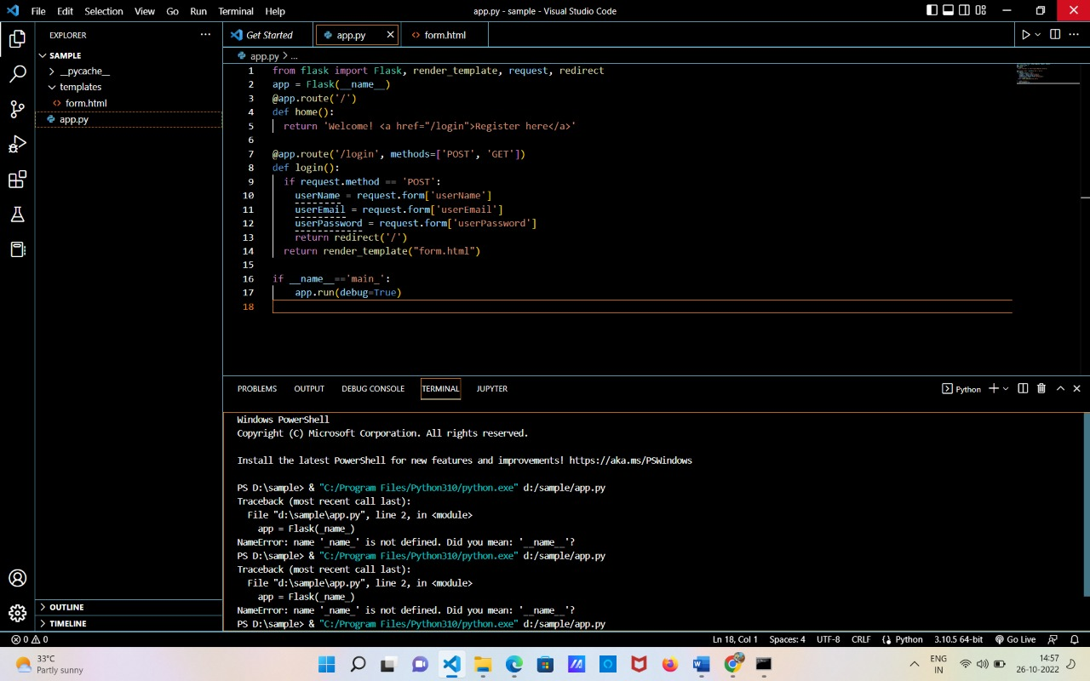

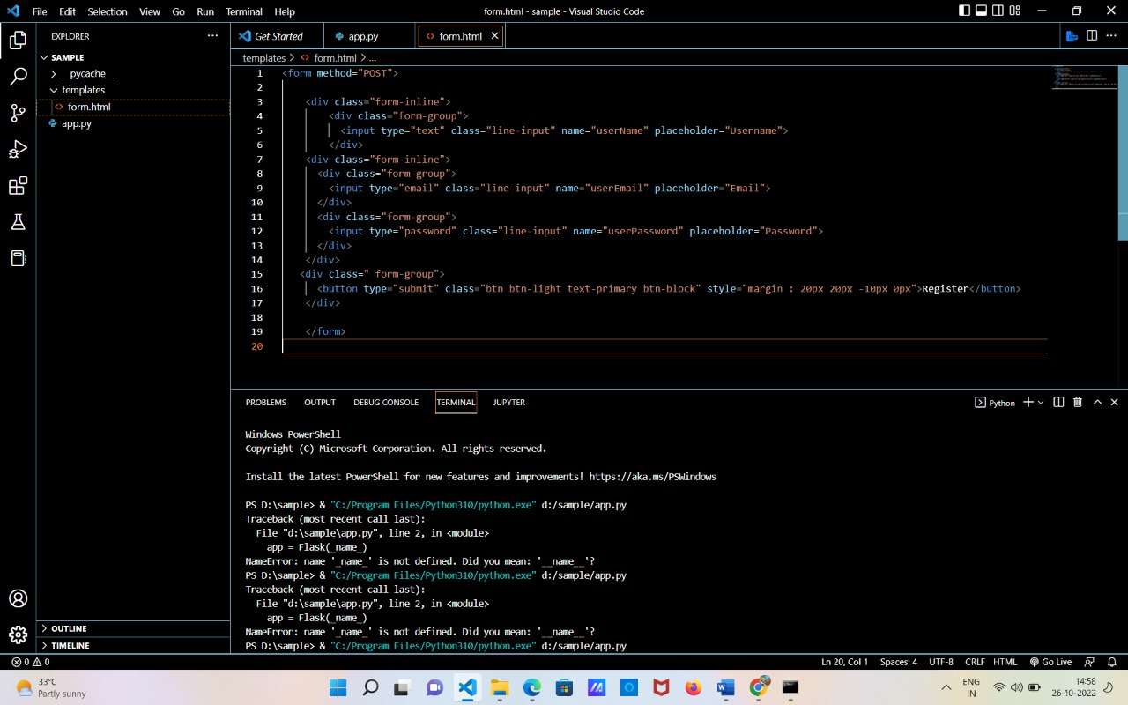

OUTPUT:

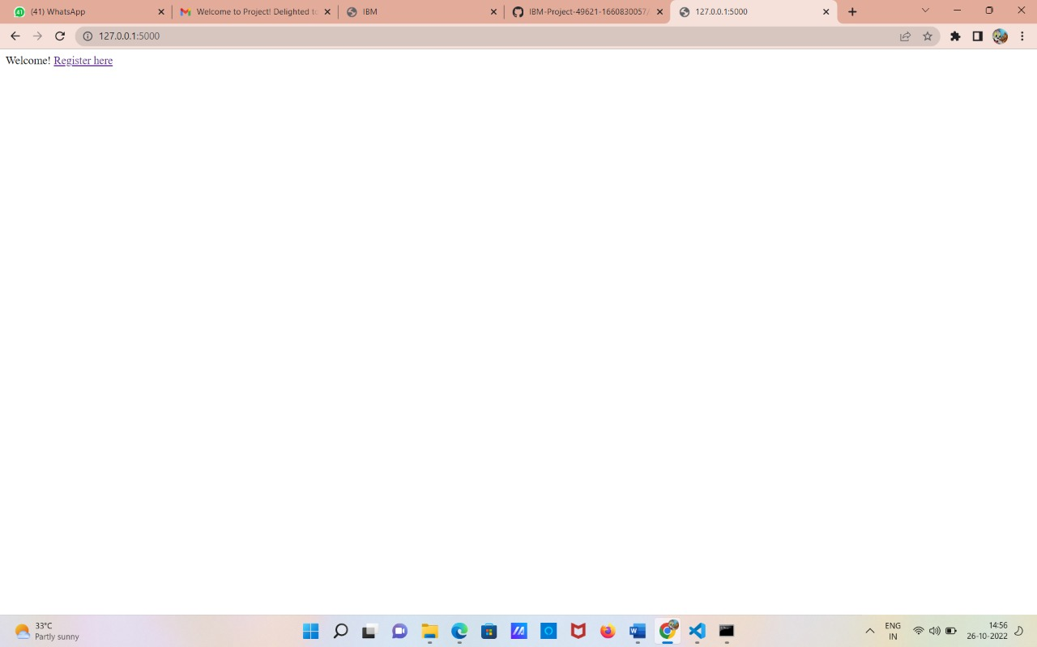

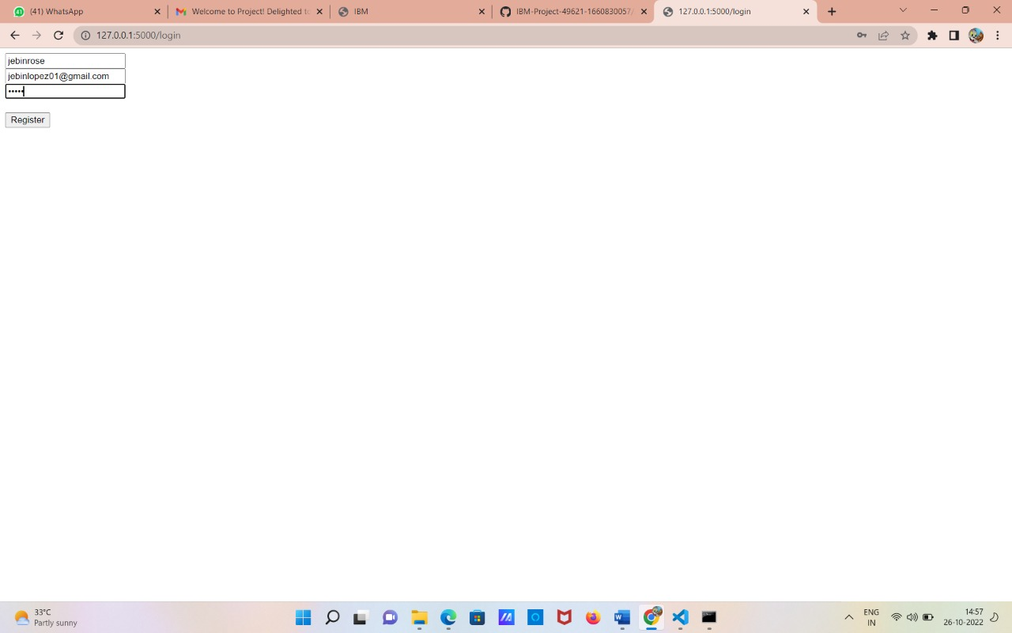

**2.Develop a flask program which should contain atleast 5 packages used from pypi.org**

**PACKAGES:**

import click

from jinja2 import Template

import camelcase

import numpy as np

import requests

**# CLICK**

@click.command()

@click.argument('name', default=’JEBIN ROSE REYON BELL')

def hello(name):

click.echo(f'Hello {name}')

if __name__ == '__main__':

hello()

**# JINJA2:**

name = input("Enter your name: ")

tm = Template("Hello {{ name }}")

msg = tm.render(name=name)

print(msg)

**# CAMELCASE:**

c = camelcase.CamelCase()

txt = "hi buddyy , wanna hangout?"

print(" CAMELCASE ")

print(c.hump(txt))

print("\n")

**#NUMPY:**

arr1 = np.array([1, 2, 3, 4, 5])

arr2 = np.array([2, 4, 5, 6, 7])

print(" NUMPY ")

print(arr1+ arr2)

print(type(arr2))

print("\n")

**#REQUEST:**

r = requests.get('https://www.netflix.com/in/')

r.status_code

print(" REQUESTS ")

print(r.headers)

print("\n")

**CODE:**

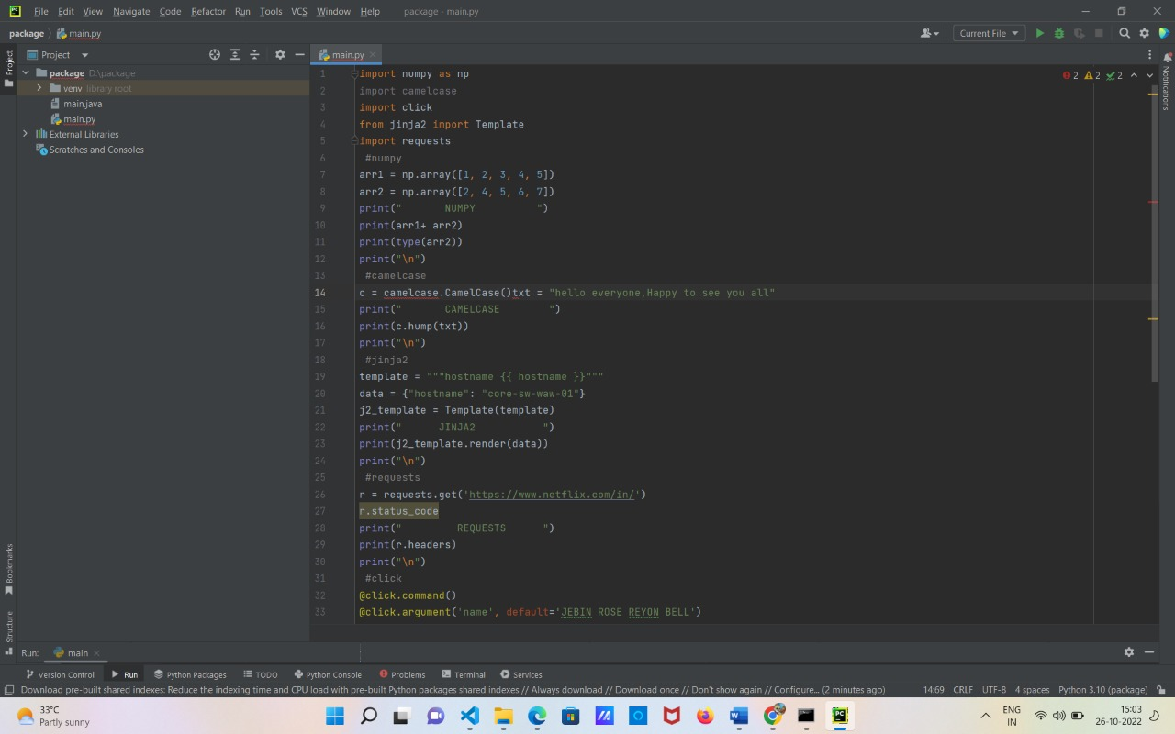

**OUTPUT:**

